**MODULE 4) CSS and CSS3**

**Q-1   What are the benefits of  using CSS?**

**Ans.** Cascading Style Sheets (CSS)  is the W3C standard for defining the presentation of documents written in HTML,XHTML and in fact, any XML language. Presentation HTML never gets close to offering the kind of controls over type, backgrounds and layout that is possible with CSS. The **advantages** of css given as under:

   ━  Easy to create webpage

   ━  CSS saves time

   ━  Pages loader faster

   ━  Easy maintain

   ━  Supported by multiple browser

   ━  Global web browser

**Q-2  What are the disadvantages of CSS?**

**Ans.** The **disadvantages** of CSS are as under:

    ━  CSS, CSS1 Upto CSS3 ,result in creating of confusion of among web browsers.

    ━  CSS create limited Security.

    ━  Cross browsers issues.

    ━  CSS improving all the times.

**Q-3  What is the difference between CSS2 and CSS3?**

**Ans.**

**Difference:**

       ━  In CSS2,CSS splits up different sections of the code in modules.In CSS3,CSS and HTML

           were put into a single file,there were no concepts of modules before.

       ━  In CSS2,there were new ways you can write CSS rules with a bunch of CSS selectors.

           In CSS3,there were no new ways of writing the CSS rules.

       ━  There is no backward compatiblity with CSS2.There is backward Compatibility maintained

          with CSS3.

       ━ CSS2 doesn’t supports the Border-Box property.CSS3 supports the Border-Box property.

       ━  CSS2 can be used to only web safe fonts.CSS3 can be used special fonts such as

           Those in Google Fonts,TypeCast etc..

**Q-4  Name a few CSS style components .**

**Ans.** CSS style components are as given:

      ━  Color

      ━  Background Color

      ━  Border

      ━  Width

      ━  Font-size

**Q-5  What do you understand about CSS opacity ?**

**Ans.** The opacity CSS property sets the opacity of an element.Opacity is the degree to which content behind an element is hidden,and is the opposite of transparency.

**Q-6  How can the background color of an element be changed?**

**Ans.** To give (!important) importance to an element, we can change the background color of an element.

**Ex..**

<html>

      <head>

         <title>Document</title>

         <style>

           .one{background-color:green !important}

         </style>

      </head>

      <body>

         <p class = “one”  style=”background-color: blue”>Good Morning</p>

      </body>

    </html>

**Q-7  How can image repetition of the backup be controlled?**

**Ans.** To control the repetition of an image in the background,use the background-repeat property.You can use no-repeat value for the background-repeat property if you do not want to repeat an image,in this case,the image will display only once.

**Ex..**

   <style>

     body {

        background-image: url(image.jpg);

        background-repeat: no-repeat;

       }

   </style>

**Q-8  What is the use of background-position property?**

**Ans.** The background-position property in CSS is mainly used to set the initial position of the background image ie., it is used to set an image at a certain position.

**Ex..**

   <style>

        body {

        background-image: url(image.jpg);

        background-repeat: no-repeat;

        background-position:inherit;

       }

   </style>

**Q-9  Which property controls the image scroll in the background?**

**Ans.** The background-attachment property controls the image scroll in the background.

 The background-attachment property sets whether a background image scrolls with the rest of

 Of the page , or is fixed.

**Ex..**

   <style>

       body {

        background-image: url(image.jpg);

        background-repeat: no-repeat;

        background-position:top center;

        background-attachment:fixed;

       }

   </style>

**Q-10  Why should background and color be used as separate properties?**

**Ans.** Background and color are separate properties because they can be used for different purposes.The background property is used to set the background color or image of an element,while the color property is used to set the text color of that element.

**Q-11  How to center block elements using CSS1?**

**Ans.**

There are two ways of centering block level elements:

1. By setting the properties margin-left and margin-right to auto and width to some explicit value:

BODY {width: 30em; background: cyan;}

P {width: 22em; margin-left: auto; margin-right: auto}

2:

TABLE {margin-left: auto; margin-right: auto; width: 400px;}

In most legacy browsers, a table's width is by default determined by its content. In CSS-conformant browsers, the complete width of any element (including tables) defaults to the full width of its parent element's content area. As browsers become more conformant, authors will need to be aware of the potential impact on their designs.

    <style>

        *{

            margin:0px;

            padding:0px;

            box-sizing: border-box;

        }

        body {

            background: brown;

        }

        #one {

            background: black;

            color:white;

            text-align: center;

        }

        /* For centering the element */

        #one {

            width:300px;

            margin:10rem auto;

        }

</style>

<body>

    <div id=”one”>

      <p>this is a box</p>

    </div>

</body>

**Q-12  How to maintain the CSS specifications?**

**Ans.**  The CSS specifications are maintained by the World Wide Web Consortium (W3C). Even though every browser supports CSS, there are many inconsistencies in the supported specification version. Some browsers even have their own implementation of the specification and have proprietary (vendor) prefixes.

**Q-13 What are the ways to integrate CSS as a web page?**

**Ans.**  There are three ways to integrate CSS as a web page:

       1.Inline CSS-by using the style attribute inside HTML elements.

       2.Internal CSS-by using a <style> element in the <head> section.

       3.External CSS-by using a <link> element to link to an external CSS file.

**Q-14  What are embedded style sheets?**

**Ans.** Embedded style sheets allow  to define styles for a particular HTML document as a whole in one place. This is done by embedding the <style></style> tags containing the CSS properties in the head of our document.

**Q-15  What are the External style sheets?**

**Ans**.An external style sheet is a separate CSS file that can be accessed by creating a link within the head section of the webpage. Multiple webpages can use the same link to access the stylesheet. The link to an external style sheet is placed within the head section of the page.

**Ex..**

    <head>

        <link rel="stylesheet" href=one.css>

        <title>document</title>

     </head>

**Q-16  What are the advantages and disadvantages of using external style sheets?**

**Ans.**

**Advantages:**

      ━  Since, the CSS code is in a separate document, our HTML files will have a clean

          structure and are smaller in size.

      ━  We can use the same .css file for multiple pages.

**Disadvantages:**

     ━  Our pages may not be rendered correctly until the external CSS is loaded.

     ━   Uploading or linking to multiple CSS files can increase  site’s download time.

**Q-17  What is the meaning of the CSS selector?**

**Ans.**  A CSS selector is the first part of a CSS Rule. It is a pattern of elements and other terms that tell the browser which HTML elements should be selected to have the CSS property values inside the rule applied to them.

**Q-18  What are the media types allowed by CSS?**

**Ans.** The most commenly used media feature is width.By restricting CSS rules to a certain width device displaying a web page,one can tailor of the page’s representation of devices(i.e. smartphones -320px to 480px , tablets - 481px to 768px , netbook,small-screen -769px to 1024px , desktop,large-screen - 1025px to 1600px) with varying screen resolution.

**Q-19  What is the rule set?**

**Ans.**  A ruleset provides a unit of execution for rules and Decision Tables. In addition, rulesets provide a unit of sharing for rules; rules belong to a ruleset. Multiple rulesets can be executed in order. This is called rule flow.

**Q-20  Create image gallery using display grid with responsive.**

**Ans.**

**<!DOCTYPE html>**

**<html lang="en">**

**<head>**

**<meta charset="UTF-8">**

**<meta http-equiv="X-UA-Compatible" content="IE=edge">**

**<meta name="viewport" content="width=device-width, initial-scale=1.0">**

**<title>Document</title>**

**<!-- font cdn -->**

**<link rel="stylesheet" href="https://cdnjs.cloudflare.com/ajax/libs/font-awesome/6.4.0/css/all.min.css" />**

**<style>**

**\* {**

**margin: 0;**

**padding: 0;**

**box-sizing: border-box;**

**}**

**.container {**

**display: grid;**

**grid-template-columns: repeat(4);**

**background-color: black;**

**}**

**.one {**

**padding: 15px;**

**margin: 5px;**

**}**

**#two1 {**

**grid-column: 1/7;**

**grid-row: 1/2;**

**background-image: url(https://media.istockphoto.com/id/846730696/photo/portrait-teenager.jpg?s=170667a&w=is&k=20&c=WkQPsXbF5YZPqX60I2nkvRJwzu8jTldaLo9T0IJ6IuU=);**

**background-repeat: no-repeat;**

**background-size: cover;**

**}**

**#two2 {**

**grid-column: 7/10;**

**grid-row: 1/2;**

**background-image: url(https://www.familyfuntwincities.com/wp-content/uploads/2015/07/tm-big-stone-mini-golf-3.jpg);**

**background-repeat: no-repeat;**

**background-size: cover;**

**}**

**#two3 {**

**grid-column: 10/11;**

**grid-row: 1/5;**

**color: white;**

**background-color: black;**

**text-align: right;**

**}**

**#two4 {**

**grid-column: 1/3;**

**grid-row: 2/3;**

**background-image: url(https://media.istockphoto.com/id/846730696/photo/portrait-teenager.jpg?s=170667a&w=is&k=20&c=WkQPsXbF5YZPqX60I2nkvRJwzu8jTldaLo9T0IJ6IuU=);**

**background-repeat: no-repeat;**

**background-size: cover;**

**}**

**#two5 {**

**grid-column: 3/8;**

**grid-row: 2/3;**

**background-image: url(https://wallpapercave.com/wp/wp5164931.jpg);**

**background-repeat: no-repeat;**

**background-size: cover;**

**}**

**#two6 {**

**grid-column: 8/10;**

**grid-row: 2/3;**

**background-image: url(https://media.istockphoto.com/id/609802454/photo/portrait-of-a-fresh-and-lovely-women-on-black-background.jpg?s=612x612&w=0&k=20&c=2IA_oj25K4GPUoRVXhXd1DUM43G4m5PpLCCL5M4zK9E=);**

**background-repeat: no-repeat;**

**background-size: cover;**

**}**

**#two7 {**

**grid-column: 1/5;**

**grid-row: 3/4;**

**background-image: url(https://pbs.twimg.com/media/E-8i9CSXoAARmA4.jpg);**

**background-repeat: no-repeat;**

**background-size: cover;**

**}**

**#two8 {**

**grid-column: 5/10;**

**grid-row: 3/4;**

**background-image: url(https://e1.pxfuel.com/desktop-wallpaper/878/112/desktop-wallpaper-beautiful-girls-beautiful-girls-beautiful-girls-pic-foreign-girl-thumbnail.jpg);**

**background-repeat: no-repeat;**

**background-size: cover;**

**}**

**#two9 {**

**grid-column: 1/4;**

**grid-row: 4/5;**

**background-image: url(https://encrypted-tbn0.gstatic.com/images?q=tbn:ANd9GcQ846_JWeHLeKrjELJ4q1ewlt3b0aRl4UZPyw&usqp=CAU);**

**background-repeat: no-repeat;**

**background-size: cover;**

**}**

**#two10 {**

**grid-column: 4/7;**

**grid-row: 4/5;**

**background-image: url(https://media.istockphoto.com/id/1283569589/photo/woman-breaths-fresh-air-holding-coffee-cup-in-autumn.jpg?s=612x612&w=0&k=20&c=1_dOmLSTaWEwqMn6RiI0AvqefVkdmTJeiVzchtfqVOo=);**

**background-repeat: no-repeat;**

**background-size: cover;**

**}**

**#two11 {**

**grid-column: 7/10;**

**grid-row: 4/5;**

**background-image: url(https://www.w3schools.com/css/img_5terre.jpg);**

**background-repeat: no-repeat;**

**background-size: cover;**

**}**

**#nav {**

**font-size: small;**

**margin-bottom: 500px;**

**float: right;**

**padding-bottom: 10px;**

**}**

**#heading {**

**margin-bottom: 40px;**

**}**

**.section-main li {**

**list-style: none;**

**margin-bottom: 10px;**

**}**

**.section-main li a {**

**text-decoration: none;**

**color: white;**

**}**

**.section-main li a:hover {**

**color: red;**

**}**

**#changecolor {**

**color: red;**

**}**

**#change {**

**color: red;**

**}**

**.second i {**

**height: 30px;**

**width: 30px;**

**margin-top: 30px;**

**}**

**</style>**

**</head>**

**<body>**

**<div class="container">**

**<div class="one" id="two1"></div>**

**<div class="one" id="two2"></div>**

**<div class="one" id="two3">**

**<h3 id="heading">SHUTTER</h3>**

**<div id="nav">**

**<ul class="section-main">**

**<li class="section"><a id="changecolor" href="#">HOME</a></li>**

**<li class="section"><a href="#">PHOTOS</a></li>**

**<li class="section"><a href="#">BIO</a></li>**

**<li class="section"><a href="#">BLOG</a></li>**

**<li class="section"><a href="#">CONTACT</a></li>**

**</ul>**

**<div class="second">**

**<i class="fa-brands fa-facebook-f"></i>**

**<i class="fa-brands fa-twitter"></i>**

**<i class="fa-brands fa-instagram"></i>**

**</div>**

**</div>**

**</div>**

**<div class="one" id="two4"></div>**

**<div class="one" id="two5"></div>**

**<div class="one" id="two6"></div>**

**<div class="one" id="two7"></div>**

**<div class="one" id="two8"></div>**

**<div class="one" id="two9"></div>**

**<div class="one" id="two10"></div>**

**<div class="one" id="two11"></div>**

**</div>**

**</body>**

**</html>**

**Output:**

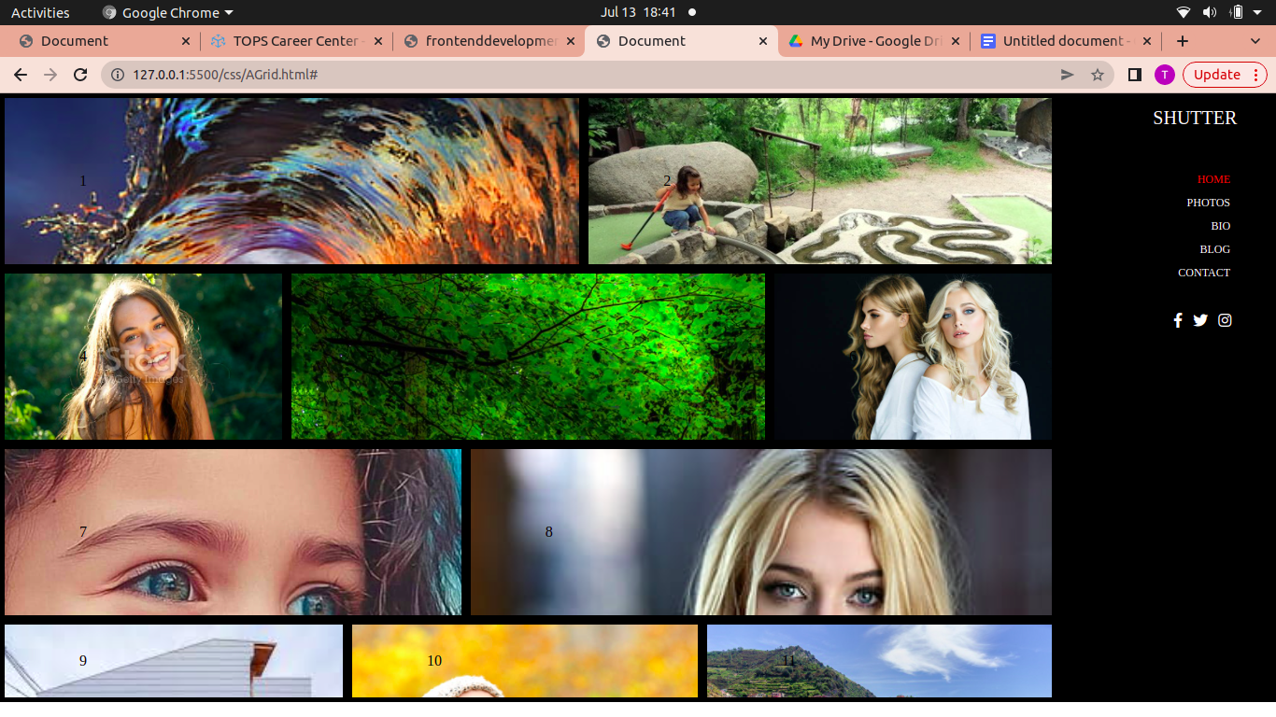

**Q-21  Create below example with the help of clip path.**

**Ans.**

<!DOCTYPE html>

<html lang="en">

<head>

    <meta charset="UTF-8">

    <meta name="viewport" content="width=device-width, initial-scale=1.0">

    <title>Document</title>

    <style>

        * {

            margin: 0;

            padding: 0;

            box-sizing: border-box;

        }

        .container {

            margin: 0px 100px;

        }

        .container-fulid {

            margin: 0 0px;

        }

        /* Main img section */

        .main {

            position: relative;

        }

        .layout1 {

            height: 404px;

            width: 100%;

            position: absolute;

            z-index: 555;

        }

        .img01,

        .img02 {

            height: 465px;

            width: 100%;

            position: absolute;

        }

        .img01 {

            z-index: 555;

        }

        .img02 {

            z-index: 777;

        }

        /* navigation bar */

        .written-section {

            z-index: 1111;

            position: relative;

            color: white;

        }

        .navbar {

            z-index: 1111;

            position: relative;

            top: 10px;

            display: flex;

            align-items: center;

            justify-content: space-between;

        }

        .logo {

            display: flex;

        }

        #logo1 {

            width: 20px;

            height: 25px;

            background-color: white;

            color: black;

            font-size: 20px;

            text-align: center;

        }

        #logo2 {

            text-align: center;

            height: 25px;

            width: 50px;

            border: 2px solid white;

            color: white;

            font-size: 20px;

        }

        nav ul li {

            list-style: none;

            display: inline-block;

            padding: 5px 15px;

        }

        nav ul li a {

            text-decoration: none;

            color: white;

        }

        nav ul li a:hover {

            color: #db0808;

        }

        #color {

            color: #db0808;

        }

        .short-heading {

            margin-top: 80px;

            text-align: center;

            font-size: 20px;

            font-weight: 300;

        }

        .welcome {

            display: flex;

            justify-content: space-between;

            align-items: center;

        }

        .left {

            height: 20px;

            width: 20px;

            background-color: #c41616;

            background-image: url(https://www.iconpacks.net/icons/2/free-arrow-left-icon-3099-thumb.png);

            background-repeat: no-repeat;

            color: #fff;

            background-position: center;

            background-size: contain;

        }

        .right {

            height: 20px;

            width: 20px;

            background-color: #c41616;

            background-image: url(Images/slider2.png);

            background-repeat: no-repeat;

            background-position: center;

            background-size: contain;

        }

        .center {

            font-weight: 800;

            font-size: 70px;

        }

        .about-this {

            text-align: center;

            margin: 20px 300px;

        }

        .d-line {

            display: flex;

            color: #000;

            align-items: center;

            justify-content: center;

        }

        .d-line0,

        .d-line2 {

            width: 100px;

            height: 1px;

            border: 3px solid #6a6a6a;

        }

        .d-line1 {

            width: 10px;

            height: 10px;

            border-radius: 10px;

            background-color: #c41616;

        }

        .button {

            position: absolute;

            top: 350px;

            left: 40%;

        }

        .define {

            height: 100ox;

            width: 100px;

            background-color: tomato;

            padding: 10px;

            text-decoration: none;

            font-size: 15px;

            text-transform: uppercase;

            color: white;

            padding-left: 20px;

        }

        .define1 {

            height: 100ox;

            width: 100px;

            border: 2px solid white;

            padding: 8px;

            text-decoration: none;

            font-size: 15px;

            text-transform: uppercase;

            color: white;

            padding-left: 20px;

        }

        .define:hover {

            background: #fff;

            color: black;

        }

        .define1:hover {

            background: tomato;

        }

        .anything {

            position: absolute;

            top: 435px;

            left: 650px;

            width: 64px;

            height: 64px;

            border-radius: 32px;

            background-color: #f4f5f9;

            background-image: url(images/ero.png);

            background-repeat: no-repeat;

            background-position: center;

        }

        .container2 {

            position: absolute;

            top: 500px;

        }

        .section {

            display: flex;

            align-items: center;

            margin: 20px 100px;

        }

        .section1 {

            padding: 0 20px;

        }

        .sub-img {

            padding: 0 20px;

        }

        .sub-title {

            color: #db0808;

            padding: 10px;

            text-transform: uppercase;

        }

        .line {

            width: 50px;

            height: 1px;

            background-color: #f4f5f9;

            border: 3px solid #6a6a6a;

            margin: 0 40px;

        }

    </style>

</head>

<body>

    <section class="main">

        <img class="img01" src="Images/backgroundLayout.png" alt="" srcset="">

        <img class="layout1" src="Images/NewImage.png" alt="" srcset="">

        <img class="img02" src="Images/Layout.png" alt="" srcset="">

    </section>

    <section class=" written-section">

        <div class="navbar container">

            <div class="logo">

                <p id="logo1">L</p>

                <p id="logo2">ogo</p>

            </div>

            <nav>

                <ul>

                    <li><a id="color" href="#">HOME</a></li>

                    <li><a href="#">ABOUTUS</a></li>

                    <li><a href="#">PORTFOLIO</a></li>

                    <li><a href="#">PRICING</a></li>

                    <li><a href="#">TEAM</a></li>

                    <li><a href="#">BLOG</a></li>

                    <li><a href="#">CONTACT</a></li>

                </ul>

            </nav>

        </div>

        <h6 class="container short-heading">Our Clients Are Our First Priority</h6>

        <div class="welcome container-fulid">

            <div class="left"></div>

            <div class="center">Welcome to sky</div>

            <div class="right"></div>

        </div>

        <div class="d-line">

            <p class="d-line0"></p>

            <p class="d-line1"></p>

            <p class="d-line2"></p>

        </div>

        <div class="about-this">Lorem ipsum, dolor sit amet consectetur adipisicing elit. Vel sed quo laudantium optio

            itaque pariatur atque, nisi aliquam, dignissimos reiciendis excepturi quaerat quos repudiandae

            exercitationem repellat! Corporis natus labore repudiandae quo, modi nemo eos ipsa, pariatur provident

            voluptatum dolore illo quos rerum ducimus expedita earum.

        </div>

        <div class="button">

            <a class="define" href="#">Get Started Now</a>

            <a class="define1" href="#">Learn More</a>

        </div>

        <div class="anything"></div>

    </section>

    <div class="container2 section">

        <div class="section1">

            <img class="sub-img" src="Images/ImgF.png" alt="" srcset="">

            <p class="sub-title">Seek Design</p>

            <div class="line"></div>

            <p class="lorem">

                Lorem ipsum dolor, sit amet consectetur

                adipisicing elit. Excepturi perferendis

                eius distinctio aut quia et?

            </p>

        </div>

        <div class="section1">

            <img class="sub-img" src="Images/twoimg.png" alt="" srcset="">

            <p class="sub-title">Clean Code</p>

            <div class="line"></div>

            <p class="lorem">

                Lorem ipsum dolor, sit amet consectetur

                adipisicing elit. Excepturi perferendis

                eius distinctio aut quia et?

        </div>

        <div class="section1">

            <img class="sub-img" src="Images/threeimg.png" alt="" srcset="">

            <p class="sub-title">Creative Ideals</p>

            <div class="line"></div>

            <p class="lorem">

                Lorem ipsum dolor, sit amet consectetur

                adipisicing elit. Excepturi perferendis

                eius distinctio aut quia et?

            </p>

        </div>

        <div class="section1">

            <img class="sub-img" src="Images/fourimg.png" alt="" srcset="">

            <p class="sub-title">Free Support</p>

            <div class="line"></div>

            <p class="lorem">

                Lorem ipsum dolor, sit amet consectetur

                adipisicing elit. Excepturi perferendis

                eius distinctio aut quia et?

            </p>

        </div>

    </div>

</body>

</html>

**Output=**

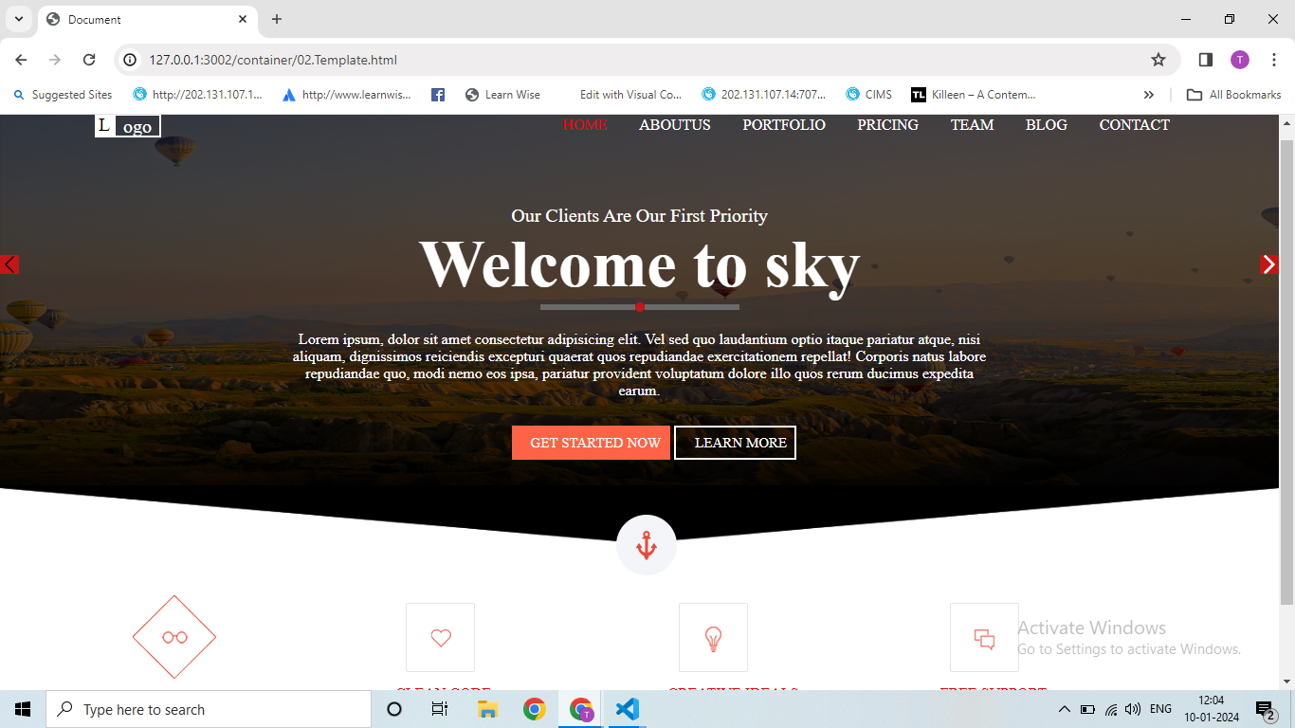

**Q-22 Multiple background one side bg-color other side contain image as bg**

**Ans.**

**<!DOCTYPE html>**

**<html lang="en">**

**<head>**

**<meta charset="UTF-8" />**

**<meta http-equiv="X-UA-Compatible" content="IE=edge" />**

**<meta name="viewport" content="width=device-width, initial-scale=1.0" />**

**<title>Document</title>**

**<style>**

**\* {**

**margin: 0;**

**padding: 0;**

**box-sizing: border-box;**

**}**

**.main-container {**

**display: flex;**

**height: 700px;**

**}**

**.main-container .container-one {**

**width: 50%;**

**background-color: #202020;**

**}**

**.main-container .container-two {**

**width: 50%;**

**background-image: url(images/Service.png);**

**}**

**.text-area {**

**display: flex;**

**padding-top: 80px;**

**padding-left: 240px;**

**gap: 20px;**

**}**

**.text-area h3 {**

**text-transform: uppercase;**

**color: #f4f5f9;**

**font-size: 35px;**

**font-weight: 700;**

**letter-spacing: 5px;**

**}**

**.cover {**

**width: 587px;**

**height: 74px;**

**line-height: 29px;**

**width: 6px;**

**height: 36px;**

**background-color: #e74c3c;**

**}**

**.web-design .web1 {**

**color: red;**

**padding-top: 60px;**

**font-size: 18px;**

**font-weight: 600;**

**text-transform: uppercase;**

**text-align: right;**

**width: 587px;**

**height: 74px;**

**line-height: 29px;**

**}**

**.web-design .web2 {**

**padding-top: 15px;**

**width: 587px;**

**font-size: 14px;**

**color: #999999;**

**font-weight: 400;**

**font-family: "Source Sans Pro";**

**text-align: right;**

**}**

**.web-design .web3 {**

**padding-top: 5px;**

**width: 587px;**

**font-size: 14px;**

**color: #999999;**

**font-weight: 400;**

**font-family: "Source Sans Pro";**

**text-align: right;**

**}**

**.print-design .print1 {**

**color: red;**

**padding-top: 60px;**

**font-size: 18px;**

**font-weight: 600;**

**text-transform: uppercase;**

**text-align: right;**

**width: 587px;**

**height: 74px;**

**line-height: 29px;**

**}**

**.print-design .print2 {**

**padding-top: 15px;**

**width: 587px;**

**font-size: 14px;**

**color: #999999;**

**font-weight: 400;**

**font-family: "Source Sans Pro";**

**text-align: right;**

**}**

**.print-design .print3 {**

**padding-top: 5px;**

**width: 587px;**

**font-size: 14px;**

**color: #999999;**

**font-weight: 400;**

**font-family: "Source Sans Pro";**

**text-align: right;**

**}**

**.container-two .one {**

**width: 64px;**

**height: 64px;**

**border-radius: 32px;**

**background-color: #f4f5f9;**

**background-image: url(images/Forma0.png);**

**background-repeat: no-repeat;**

**background-position: center;**

**position: absolute;**

**top: 180px;**

**left: 635px;**

**}**

**.container-two .two {**

**width: 64px;**

**height: 64px;**

**border-radius: 32px;**

**background-color: #f4f5f9;**

**background-image: url(images/Forma1.png);**

**background-repeat: no-repeat;**

**background-position: center;**

**position: absolute;**

**top: 315px;**

**left: 635px;**

**}**

**.container-two .three {**

**width: 64px;**

**height: 64px;**

**border-radius: 32px;**

**background-color: #f4f5f9;**

**background-image: url(images/Forma2.png);**

**background-repeat: no-repeat;**

**background-position: center;**

**position: absolute;**

**top: 440px;**

**left: 635px;**

**}**

**</style>**

**</head>**

**<body>**

**<div class="main-container">**

**<!-- side one -->**

**<div class="container-one">**

**<div class="text-area">**

**<h3>Our Services</h3>**

**<p class="cover"></p>**

**</div>**

**<div class="web-design">**

**<p class="web1">Web Design</p>**

**<p class="web2">**

**Lorem ipsum, dolor sit amet consectetur adipisicing elit. Corrupti**

**qui vero officia**

**</p>**

**<p class="web3">Lorem ipsum dolor sit amet.</p>**

**</div>**

**<div class="print-design">**

**<p class="print1">Print Design</p>**

**<p class="print2">**

**Lorem ipsum, dolor sit amet consectetur adipisicing elit. Corrupti**

**</p>**

**<p class="print3">**

**Lorem ipsum, dolor sit amet consectetur adipisicing elit.**

**</p>**

**</div>**

**<div class="print-design">**

**<p class="print1">Photography</p>**

**<p class="print2">**

**Lorem ipsum, dolor sit amet consectetur adipisicing elit. Corrupti**

**qui vero officia**

**</p>**

**<p class="print3">**

**Lorem ipsum dolor sit, amet consectetur adipisicing elit. Saepe, ea?**

**</p>**

**</div>**

**</div>**

**<!-- side two -->**

**<div class="container-two">**

**<div class="one"></div>**

**<div class="two"></div>**

**<div class="three"></div>**

**</div>**

**</div>**

**</body>**

**</html>**

**Output:**

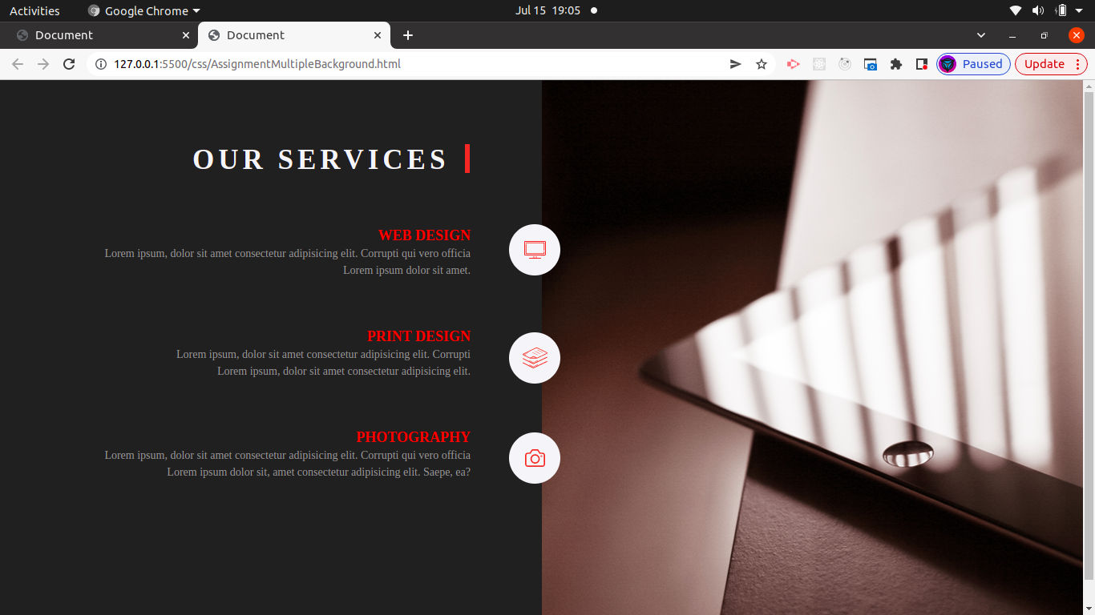

**Q-23 Create below example using css waves generator.**

**Ans.**

**<!DOCTYPE html>**

**<html lang="en">**

**<head>**

**<meta charset="UTF-8" />**

**<meta http-equiv="X-UA-Compatible" content="IE=edge" />**

**<meta name="viewport" content="width=device-width, initial-scale=1.0" />**

**<title>Document</title>**

**<style>**

**\* {**

**margin: 0;**

**padding: 0;**

**box-sizing: border-box;**

**}**

**.main {**

**height: 650px;**

**width: 100%;**

**background-color: white;**

**}**

**.container1 {**

**height: 650px;**

**width: 100%;**

**background-color: white;**

**}**

**#img1 {**

**position: absolute;**

**top: 0;**

**}**

**#img2 {**

**position: absolute;**

**top: 200px;**

**}**

**#img3 {**

**position: absolute;**

**top: 200px;**

**}**

**.heading {**

**color: beige;**

**position: absolute;**

**top: 120px;**

**left: 600px;**

**}**

**.head {**

**padding-left: 50px;**

**padding-bottom: 10px;**

**}**

**.head2 {**

**padding-bottom: 10px;**

**}**

**.line {**

**position: absolute;**

**top: 90px;**

**left: 20px;**

**display: flex;**

**}**

**.line1 {**

**width: 100px;**

**height: 1px;**

**background-color: beige;**

**}**

**.line2 {**

**width: 10px;**

**height: 10px;**

**border-radius: 10px;**

**background-color: red;**

**position: absolute;**

**top: -3px;**

**left: 120px;**

**}**

**.line3 {**

**position: absolute;**

**top: 0;**

**left: 150px;**

**width: 100px;**

**height: 1px;**

**background-color: beige;**

**}**

**.photo1 {**

**position: absolute;**

**top: 460px;**

**left: 200px;**

**height: 50px;**

**width: 50px;**

**border-radius: 50px;**

**background-color: white;**

**border: 2px solid red;**

**background-image: url(images/photo3.png);**

**background-position: center;**

**}**

**.photo2 {**

**position: absolute;**

**top: 400px;**

**left: 480px;**

**height: 80px;**

**width: 80px;**

**border-radius: 80px;**

**background-color: white;**

**border: 2px solid red;**

**background-image: url(images/photo3.png);**

**background-position: center;**

**background-repeat: no-repeat;**

**background-size: cover;**

**}**

**.text {**

**position: absolute;**

**top: 80px;**

**left: 40px;**

**}**

**.line-1 {**

**height: 50px;**

**width: 1px;**

**background-color: silver;**

**padding-top: 5px;**

**}**

**.topic1 {**

**position: absolute;**

**top: 50px;**

**left: -30px;**

**text-transform: uppercase;**

**color: red;**

**font-size: 15px;**

**}**

**.topic2 {**

**position: absolute;**

**top: 90px;**

**left: -30px;**

**text-transform: uppercase;**

**color: white;**

**font-size: 10px;**

**}**

**.photo3 {**

**position: absolute;**

**top: 410px;**

**left: 750px;**

**height: 50px;**

**width: 50px;**

**border-radius: 50px;**

**background-color: white;**

**border: 2px solid red;**

**background-image: url(images/photo3.png);**

**background-position: center;**

**}**

**.photo4 {**

**position: absolute;**

**top: 420px;**

**left: 950px;**

**height: 50px;**

**width: 50px;**

**border-radius: 50px;**

**background-color: white;**

**border: 2px solid red;**

**background-image: url(images/photo3.png);**

**background-position: center;**

**}**

**.photo5 {**

**position: absolute;**

**top: 350px;**

**left: 1150px;**

**height: 50px;**

**width: 50px;**

**border-radius: 50px;**

**background-color: white;**

**border: 2px solid red;**

**background-image: url(images/photo3.png);**

**background-position: center;**

**}**

**</style>**

**</head>**

**<body>**

**<div class="main">**

**<div class="container1">**

**<p>**

**<img id="img1" src="images/csswaves.png" alt="" srcset="" height="600px" width="100%" />**

**<img id="img2" src="images/shape174.png" alt="" srcset="" width="100%" />**

**<img id="img3" src="images/shape17.png" alt="" srcset="" width="100%" />**

**<div class="heading">**

**<h1 class="head">Our Services</h1>**

**<p class="head2">Meet the craziest team.Share your thoughts with team.</p>**

**<div class="line">**

**<p class="line1"></p>**

**<p class="line2"></p>**

**<p class="line3"></p>**

**</div>**

**</div>**

**</p>**

**<div class="photo">**

**<div class="photo1"></div>**

**<div class="photo2">**

**<div class="text">**

**<p class="line-1"></p>**

**<h3 class="topic1">Web Designer</h3>**

**<p class="topic2">UI/UX Designer</p>**

**</div>**

**</div>**

**<div class="photo3"></div>**

**<div class="photo4"></div>**

**<div class="photo5"></div>**

**</div>**

**</div>**

**</div>**

**</body>**

**</html>**

**OUTPUT=**

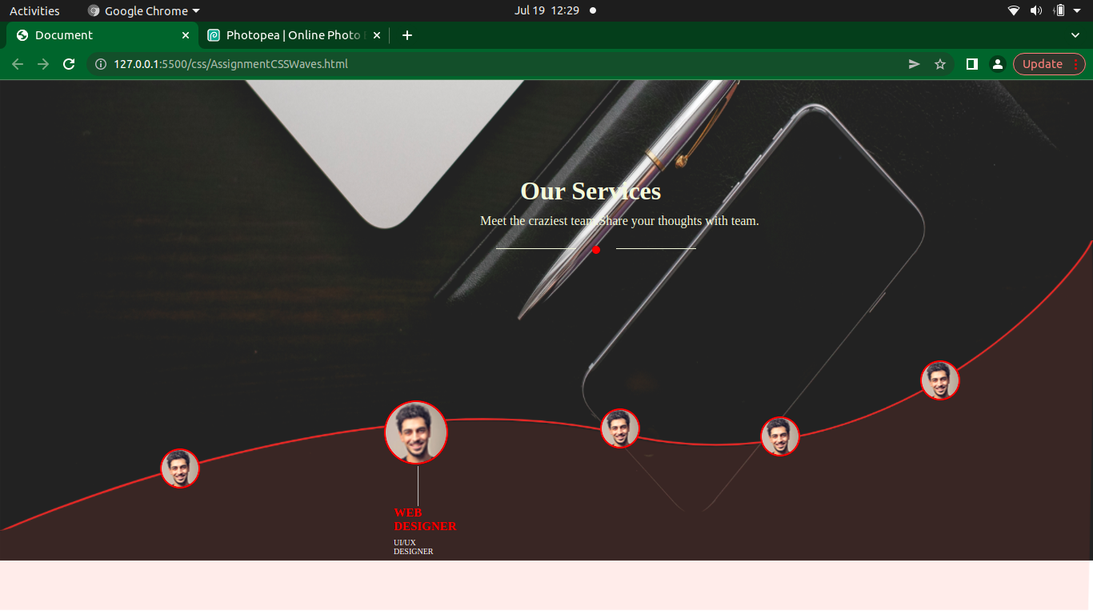

**Q-24  Create Layouts**

**Ans.**

**<!DOCTYPE html>**

**<html lang="en">**

**<head>**

**<meta charset="UTF-8" />**

**<meta http-equiv="X-UA-Compatible" content="IE=edge" />**

**<meta name="viewport" content="width=device-width, initial-scale=1.0" />**

**<title>Document</title>**

**<style>**

**\* {**

**margin: 0;**

**padding: 0;**

**box-sizing: border-box;**

**}**

**.main-container {**

**height: 600px;**

**width: 100%;**

**background-color: white;**

**}**

**/* section1 */**

**.hero {**

**display: flex;**

**}**

**.one-container {**

**background-color: white;**

**margin: 20px;**

**}**

**.heading {**

**height: 120px;**

**width: auto;**

**text-align: center;**

**padding-top: 40px;**

**font-size: 20px;**

**background-color: gray;**

**color: white;**

**margin-bottom: 10px;**

**}**

**.text {**

**padding: 10px;**

**word-spacing: 2px;**

**font-size: 17px;**

**}**

**.text1 {**

**padding: 10px;**

**}**

**.any {**

**padding: 5px 15px;**

**text-decoration: none;**

**color: black;**

**border: 1px solid black;**

**font-size: 17px;**

**}**

**/* section2 */**

**.footer {**

**display: flex;**

**}**

**</style>**

**</head>**

**<body>**

**<div class="main-container">**

**<!-- section1 -->**

**<div class="hero">**

**<div class="one-container">**

**<h3 class="heading">Thumbnail</h3>**

**<p class="text">**

**This is a winder card with supporting text <br />below as a natural**

**lead into additional <br />content.This content is a little bit**

**longer**

**</p>**

**<p class="text1">**

**<a class="any" href="#">View</a><a class="any" href="#">Edit</a>**

**</p>**

**</div>**

**<div class="one-container">**

**<h3 class="heading">Thumbnail</h3>**

**<p class="text">**

**This is a winder card with supporting text <br />below as a natural**

**lead into additional <br />content.This content is a little bit**

**longer**

**</p>**

**<p class="text1">**

**<a class="any" href="#">View</a><a class="any" href="#">Edit</a>**

**</p>**

**</div>**

**<div class="one-container">**

**<h3 class="heading">Thumbnail</h3>**

**<p class="text">**

**This is a winder card with supporting text <br />below as a natural**

**lead into additional <br />content.This content is a little bit**

**longer**

**</p>**

**<p class="text1">**

**<a class="any" href="#">View</a><a class="any" href="#">Edit</a>**

**</p>**

**</div>**

**</div>**

**<!-- section2 -->**

**<div class="footer">**

**<div class="one-container">**

**<h3 class="heading">Thumbnail</h3>**

**<p class="text">**

**This is a winder card with supporting text <br />below as a natural**

**lead into additional <br />content.This content is a little bit**

**longer**

**</p>**

**<p class="text1">**

**<a class="any" href="#">View</a><a class="any" href="#">Edit</a>**

**</p>**

**</div>**

**<div class="one-container">**

**<h3 class="heading">Thumbnail</h3>**

**<p class="text">**

**This is a winder card with supporting text <br />below as a natural**

**lead into additional <br />content.This content is a little bit**

**longer**

**</p>**

**<p class="text1">**

**<a class="any" href="#">View</a><a class="any" href="#">Edit</a>**

**</p>**

**</div>**

**<div class="one-container">**

**<h3 class="heading">Thumbnail</h3>**

**<p class="text">**

**This is a winder card with supporting text <br />below as a natural**

**lead into additional <br />content.This content is a little bit**

**longer**

**</p>**

**<p class="text1">**

**<a class="any" href="#">View</a><a class="any" href="#">Edit</a>**

**</p>**

**</div>**

**</div>**

**</div>**

**</body>**

**</html>**

**OUTPUT=**

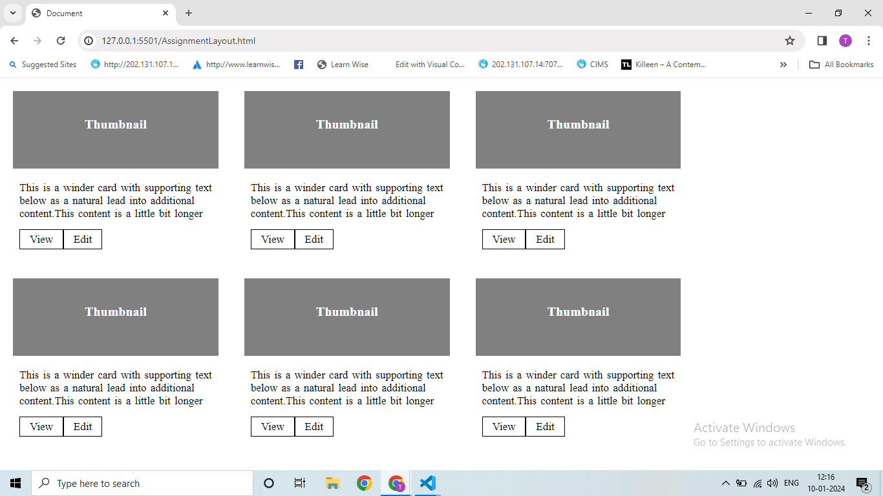

**Q-25  Create below example responsive media query.**

**Ans.**

    <!DOCTYPE html>

<html lang="en">

 <head>

   <meta charset="UTF-8" />

   <meta http-equiv="X-UA-Compatible" content="IE=edge" />

   <meta name="viewport" content="width=device-width, initial-scale=1.0" />

   <title>Document</title>

   <link

     rel="stylesheet"

     href="https://cdnjs.cloudflare.com/ajax/libs/font-awesome/6.4.0/css/all.min.css"

   />

   <style>

     * {

       margin: 0;

       padding: 0;

       box-sizing: border-box;

     }

     .container {

       position: relative;

       width: 1150px;

       height: 4699;

     }

     .container1 {

       display: flex;

       padding: 20px;

     }

     .teamflow {

       padding-left: 80px;

     }

     .navbar {

       padding-left: 150px;

     }

     .navbar ul {

       list-style-type: none;

     }

     .navbar ul li {

       display: inline;

       padding-left: 20px;

     }

     .navbar ul li a {

       text-decoration: none;

       color: black;

     }

     .definespace {

       padding-right: 50px;

     }

     .login ul {

       list-style-type: none;

     }

     .login ul li {

       display: inline;

       padding-right: 10px;

     }

     .login ul li a {

       text-decoration: none;

       color: black;

     }

     #blank {

       border: 2px solid wheat;

       padding: 5px;

       color: purple;

     }

     .discount {

       display: inline;

     }

     .savemoney {

       padding: 100px 350px 50px 450px;

     }

     #save {

       text-decoration: none;

       border-radius: 20px 20px;

       background-color: green;

       padding: 8px;

       color: wheat;

     }

     #account {

       border: 2px solid white;

       background-color: steelblue;

       text-decoration: none;

       padding: 8px;

     }

     .heading {

       text-align: center;

       font-size: 30px;

     }

     .h-similar {

       font-size: 15px;

     }

     #tryit {

       border: 2px solid white;

       background-color: purple;

       text-decoration: none;

       color: white;

       font-size: 15px;

       padding: 5px 20px;

     }

     #overview1 {

       padding: 30px 150px;

     }

     .best-team {

       padding: 0px 200px 0px 200px;

     }

     .best-team .best1 {

       text-align: center;

     }

     .best-team .logo {

       display: inline;

       padding: 0px 50px 0px 80px;

     }

     .time-line {

       display: flex;

       padding: 0px 10px 0px 50px;

     }

     .time-section {

       z-index: 1;

       position: relative;

       top: 0;

       box-shadow: 1px 0px 1px 1px black;

       height: 580px;

       width: 500px;

       background-color: white;

     }

     .time-section .time {

       padding: 10px 0px 10px 20px;

       font-size: 20px;

     }

     .border{

       height: 40px;

       width: 40px;

       border-radius: 80px;

       background-color: thistle;

       background-image: url(https://encrypted-tbn0.gstatic.com/images?q=tbn:ANd9GcSmGHJBvdL1deZTRBcf5rARsAKKc0xdECTVje3CKy23jdAb2JQQcGGX2CrfobCG8LHk8k8&usqp=CAU);

       background-repeat: no-repeat;

       background-position: center;

       background-size: cover;

     }

     .h2,.h3{

       padding-left: 50px;

       font-size: 20px;

     }

     .h3{

       font-size: 15px;

     }

     span{

       color: blue;

     }

     .message2{

       position: absolute;

       top: 150px;

       left: 50px;

       height: 50px;

       width: 80%;

       background-color: white;

       box-shadow: 1px 1px 1px 2px black;

     }

     .message3{

       position: absolute;

       top: 250px;

       left: 50px;

       height: 50px;

       width: 80%;

       background-color: white;

       box-shadow: 1px 1px 1px 2px black;

     }

     .message4{

       position: absolute;

       top: 350px;

       left: 50px;

       height: 50px;

       width: 80%;

       background-color: white;

       box-shadow: 1px 1px 1px 2px black;

     }

    .h5{

      position: absolute;

      top: 450px;

      left: 50px;

      font-size: 20px;

    }

    .h6{

     position: absolute;

     top: 470px;

     left: 50px;

    }

    .border2{

     position: absolute;

     top: 450px;

     height: 40px;

     width: 40px;

     border-radius: 80px;

     background-color: thistle;

     background-image: url(https://encrypted-tbn0.gstatic.com/images?q=tbn:ANd9GcRv-JDUrSiSwjwAat4IWhSCMJo3eqVZ4qnDiA&usqp=CAU);

     background-repeat: no-repeat;

     background-position: center;

     background-size: cover;

    }

    .message6{

     position: absolute;

       top: 500px;

       left: 50px;

       height: 50px;

       width: 80%;

       background-color: white;

       box-shadow: 1px 1px 1px 2px black;

    }

    .Product-designer{

      z-index: 2;

      position: absolute;

      top: 1200px;

      left: 352px;

      height: 450px;

      width: 450px;

      background-color: white;

      box-shadow: 1px 1px 2px 1px black;

    }

    .designer{

     position: relative;

     top: 0;

    }

    .profile{

      position: absolute;

      top: 20px;

      left: 20px;

      height: 50px;

      width: 50px;

      border-radius: 80px;

      background-color: burlywood;

      background-image: url(https://media.licdn.com/dms/image/C4E22AQHlLkHIC4qzPw/feedshare-shrink_800/0/1669643382169?e=2147483647&v=beta&t=_2zPPHwVmtjTbhR4KwSE0_t0ATDH1sCNhKagLtirMRc);

      background-size: cover;

      background-position: center;

    }

    .intro{

      position: absolute;

      top: 25px;

      left: 80px;

      font-size: 18px;

    }

    .thanks-given{

      position: absolute;

      top: 100px;

      left: 50px;

      height: 250px;

      width: 250px;

      background-color: white;

      border: 2px solid black;

    }

    .message-given{

     position: absolute;

      top: 20px;

      font-size: 18px;

    }

    .send{

      position: absolute;

      top: 400px;

      left: 400px;

    }

    #send1{

      text-decoration: none;

      color: white;

      border: 2px solid rgb(0, 93, 181);

      padding: 2px;

      background-color:  rgb(0, 93, 181);

    }

    .survey{

      position: relative;

      top: 0;

      left: 300px;

    }

    .survey1{

     height: 125px;

     width: 300px;

     background-color: white;

     box-shadow: 1px 0px 0px 1px black;

    }

    .line{

       line-height: 30px;

       width: 6px;

       height: 120px;

       background-color: purple;

    }

    .text{

      position: absolute;

      top: 10px;

      left: 10px;

      font-size: 15px;

    }

    .class1{

      display: block;

      font-size: 20px;

    }

    .resolve-survey,.plan-survey,.track-survey{

     padding-top: 30px;

     padding-left: 10px;

    }

    .class2{

      font-size: 20px;

    }

    .c-find{

      padding-top: 10px;

    }

    .work-easy{

      padding-top: 80px;

      position: relative;

      top: 0;

    }

    .work-easy .easy-head{

      text-align: center;

    }

    .work-easy .collection1{

      display: flex;

      padding-left: 100px;

    }

    .report{

      position: absolute;

      top: 150px;

      left: 140px;

    }

    .report1{

      height: 50px;

      width: 50px;

      border-radius: 50px;

      background-color: burlywood;

      background-image: url(https://media.licdn.com/dms/image/C4E22AQHlLkHIC4qzPw/feedshare-shrink_800/0/1669643382169?e=2147483647&v=beta&t=_2zPPHwVmtjTbhR4KwSE0_t0ATDH1sCNhKagLtirMRc);

      background-size: cover;

      background-position: center;

    }

    .report2{

    padding-top: 20px;

    }

    .one{

      position: absolute;

      top: 150px;

      left: 400px;

    }

    .learning{

     position: absolute;

      top: 150px;

      left: 700px;

    }

    .work-easy .collection2{

      display: flex;

      padding-left: 100px;

    }

    .one1{

      position: absolute;

      top: 300px;

      left: 140px;

    }

    .report11{

      height: 50px;

      width: 50px;

      border-radius: 50px;

      background-color: burlywood;

      background-image: url(https://media.licdn.com/dms/image/C4E22AQHlLkHIC4qzPw/feedshare-shrink_800/0/1669643382169?e=2147483647&v=beta&t=_2zPPHwVmtjTbhR4KwSE0_t0ATDH1sCNhKagLtirMRc);

      background-size: cover;

      background-position: center;

    }

    .report12{

    padding-top: 20px;

    }

    .one2{

      position: absolute;

      top: 300px;

      left: 400px;

    }

    .one3{

     position: absolute;

      top: 300px;

      left: 700px;

    }

    .work-in-day{

      display:flex;

      position: relative;

      top: 500px;

      left: 80px;

    }

    .one-side .new{

      position: absolute;

      top: 0;

      left: 80px;

    }

    .one-side .new h1{

     padding-bottom: 30px;

    }

    .one-side .new p{

     padding-bottom: 30px;

    }

    .one-side .new a{

      text-decoration: none;

      border: 2px solid purple;

      background-color: purple;

      color: white;

      padding: 5px;

    }

    .two-side{

      position: absolute;

      top: -40px;;

      left: 400px;

    }

    .customer-working{

      position: relative;

      top: 1000px;

    }

    .customer-working .customer h1{

      text-align: center;

      padding-bottom: 30px;

    }

    .customer-working .customer p{

      text-align: center;

      padding-bottom: 30px;

    }

    .customer-working .customer2{

      display: flex;

      padding: 10px 0px 0px 150px;

    }

    .person1{

      padding-right: 300px;

    }

    .person2{

      padding-right: 300px;

    }

    .person3{

      padding-right: 300px;

    }

    .customer2 .person1 .person-img1{

      height: 50px;

      width: 50px;

      border-radius: 50px;

      background-color: darkgray;

      background-image: url(https://media.licdn.com/dms/image/C4E22AQHlLkHIC4qzPw/feedshare-shrink_800/0/1669643382169?e=2147483647&v=beta&t=_2zPPHwVmtjTbhR4KwSE0_t0ATDH1sCNhKagLtirMRc);

      background-size: cover;

      background-position: center;

    }

    .customer2 .person2 .person-img2{

      height: 50px;

      width: 50px;

      border-radius: 50px;

      background-color: darkgray;

      background-image: url(https://media.licdn.com/dms/image/C4E22AQHlLkHIC4qzPw/feedshare-shrink_800/0/1669643382169?e=2147483647&v=beta&t=_2zPPHwVmtjTbhR4KwSE0_t0ATDH1sCNhKagLtirMRc);

      background-size: cover;

      background-position: center;

    }

    .customer2 .person3 .person-img3{

     height: 50px;

     width: 50px;

     border-radius: 50px;

     background-color: darkgray;

     background-image: url(https://media.licdn.com/dms/image/C4E22AQHlLkHIC4qzPw/feedshare-shrink_800/0/1669643382169?e=2147483647&v=beta&t=_2zPPHwVmtjTbhR4KwSE0_t0ATDH1sCNhKagLtirMRc);

     background-size: cover;

     background-position: center;

    }

    .name1{

      position: absolute;

      top: 210px;

      left: 210px;

    }

    .name2{

     position: absolute;

     top: 210px;

     left: 560px;

    }

    .name3{

     position: absolute;

     top: 210px;

     left: 910px;

    }

    .use-app{

      position: relative;

      top: 1100px;

      left: 150px;

      height: 150px;

      width: 800px;

      background-color: #796EFF;

    }

    .app1 h1{

      padding: 10px 0px 10px 20px;

      color: white;

      background-color: #796EFF;

    }

    .app2{

      position: absolute;

      top: 20px;

      left: 500px;

      height: 45px;

      width: 120px;

      background-color: #796EFF;

      background-image: url(https://encrypted-tbn0.gstatic.com/images?q=tbn:ANd9GcQi7cJMBtsyJ_NCRSEdOJiZxooS8mC2zxe_7A&usqp=CAU);

      background-size: cover;

      background-position: center;

    }

    .app3{

      position: absolute;

      top: 20px;

      left: 650px;

      height: 45px;

      width: 120px;

      background-color: #796EFF;

      background-image: url(https://upload.wikimedia.org/wikipedia/commons/thumb/b/b3/Download_on_the_App_Store_Badge_US-UK_RGB_wht.svg/2560px-Download_on_the_App_Store_Badge_US-UK_RGB_wht.svg.png);

      background-size: cover;

      background-position: center;

    }

    .last{

      height: 300px;

      width: 900px;

      background-color: #1D2830 ;

      position: relative;

      top: 1200px;

      left: 100px;

      display: flex;

    }

    .s-one ul{

      list-style-type: none;

      padding: 20px 50px 20px 70px;

    }

    .s-one ul li{

      background-color: #1D2830;

      padding-bottom: 30px;

    }

    .s-one ul li a{

      background-color: #1D2830;

      text-decoration: none;

      color: white;

    }

    .s-two ul{

      background-color: #1D2830;

      list-style-type: none;

      padding: 20px 50px 20px 70px;

    }

    .s-two ul li{

     background-color: #1D2830;

      padding-bottom: 30px;

    }

    .s-two ul li a{

      background-color: #1D2830;

      text-decoration: none;

      color: white;

    }

    .s-three ul{

      list-style-type: none;

      padding: 20px 50px 20px 70px;

    }

    .s-three ul li{

      padding-bottom: 30px;

    }

    .s-three ul li a{

      text-decoration: none;

      color: white;

    }

    .s-four ul{

      list-style-type: none;

      padding: 20px 50px 15px 70px;

    }

    .s-four ul li{

      padding-bottom: 30px;

    }

    .s-four ul li a{

      text-decoration: none;

      color: white;

    }

    .last-end{

      height: 10px;

      width: 900px;

      border-top: 2px solid white;

      background-color: #1D2830 ;

      position: relative;

      top: 1200px;

      left: 100px;

      padding: 20px;

    }

    .copyright{

     color: white;

     padding: 0px 5px 5px 70px;

     display: flex;

    }

    .copyright .p0{

      padding-right: 450px;

    }

    .copyright .p1{

      height: 20px;

      width: 20px;

      border-radius: 50px;

      position: absolute;

      top: 20px;

      left: 500px;

    }

    .copyright .p2{

      height: 20px;

      width: 20px;

      border-radius: 50px;

      position: absolute;

      top: 20px;

      left: 550px;

    }

    .copyright .p3{

      height: 20px;

      width: 20px;

      border-radius: 50px;

      position: absolute;

      top: 20px;

      left: 600px;

    }

    .copyright .p4{

      height: 20px;

      width: 20px;

      border-radius: 50px;

      position: absolute;

      top: 20px;

      left: 650px;

    }

   </style>

 </head>

 <body>

   <div class="container">

    <section class="section1">

     <div class="container1">

       <div class="teamflow"><em>team.flow</em></div>

       <div class="navbar">

         <ul>

           <li>

             <a href="#">How to it works</a

             ><select></select>

           </li>

           <li>

             <a href="#">Products</a

             ><select></select>

           </li>

           <li><a href="#">Pricing</a></li>

           <li class="definespace">

             <a href="#">Resources</a

             ><select></select>

           </li>

         </ul>

       </div>

       <div class="login">

         <ul>

           <li><a href="#">Log in</a></li>

           <li><a href="#" id="blank">Get Started Free</a></li>

         </ul>

       </div>

     </section>

     </div>

     <section class="section2">

      <div class="discount">

       <div class="savemoney">

         <a id="save" href="#">Save 90% of</a

         ><a id="account" href="#">Get Account of $49 ></a>

       </div>

      </div>

      <div class="heading">

       <h1 class="h1">Manage the team</h1>

       <h1 class="h2">every one wants to be on</h1>

       <p class="h-similar">

         simple platform that lets you master what great managers do bes,<br />

         as develop trust,collaborate,and drive team perfomance

       </p>

       <p>

         <input

           type="email"

           name=""

           id=""

           placeholder="name@youecompany.com"

         />

         <a id="tryit" href="#">Try it Free</a>

       </p>

      </div>

     </section>

     <div class="overview">

       <img

         id="overview1"

         src="https://img.freepik.com/free-vector/illustration-data-analysis-graph_53876-18340.jpg?w=826&t=st=1689481153~exp=1689481753~hmac=4e0427e791d79e6819f431214e8404e7f86615b52b761ac33ab7836e5a14894b"

         alt=""

         srcset=""

       />

     </div>

     <div class="best-team">

       <p class="best1">Trused by over =<b>10,000</b> world's best teams</p>

       <p class="logo">

         <img

           src="https://t3.ftcdn.net/jpg/03/99/98/60/240_F_399986042_9iSLYUNyDv8npaKP31xsIpDVFjfqGLDF.jpg"

           alt=""

           srcset=""

           height="50px"

           width="50px"

         />

       </p>

       <p class="logo">

         <img

           class="img"

           src="https://1000logos.net/wp-content/uploads/2023/01/Airbnb-logo.png"

           alt=""

           srcset=""

           height="50px"

           width="50px"

         />

       </p>

       <p class="logo">

         <img

           class="img"

           src="https://encrypted-tbn0.gstatic.com/images?q=tbn:ANd9GcTCtqvxbLdPNWdcIt1sy3xgrSIUk7miPtx_HA&usqp=CAU"

           alt=""

           srcset=""

           height="50px"

           width="50px"

         />

       </p>

       <p class="logo">

         <img

           class="img"

           src="https://www.dprgroup.com/wp-content/uploads/2018/02/hubspot-logo.jpg"

           alt=""

           srcset=""

           height="50px"

           width="50px"

         />

       </p>

     </div>

     <div class="time-line">

       <div class="time-section">

         <p class="time">Timeline</p>

         <p class="border"></p>

         <p class="heading2">

           <p class="h2">BenchMarking</p>

           <p class="h3">sent to Denise on 06/02/2020</p>

         </p>

         <p class="message">

           <p class="message2"><span>@Denise</span> can we add three more <br>analyses?</p>

         </p>

         <p class="message">

           <p class="message3"><span>@Denise</span> can we add three more <br>analyses?</p>

         </p>

         <p class="message">

           <p class="message4"><span>@Denise</span> can we add three more <br>analyses?</p>

         </p>

         <p class="heading3">

           <p class="h5">Meet Reminder</p>

           <p class="h6">sent to Denise on 06/02/2020</p>

         </p>

         <p class="border2"></p>

         <p class="message">

           <p class="message6"><span>@Denise</span> can we add three more <br>analyses?</p>

         </p>

       </div>

       <div class="Product-designer">

         <div class="designer">

           <p class="profile"></p>

           <p class="intro">Deinse Sliva <br>Product Designer</p>

           <div class="thanks-given">

             <p class="message-given">

               <span>@Peter</span>Thanks for review! <br> I will review the comments and submit   a  <br> new projects.

             </p>

           </div>

           <div class="send"><a id="send1" href="#">Send</a></div>

         </div>

       </div>

       <div class="survey">

         <div class="survey1">

           <div class="line">

             <div class="text">

               <p class="class1"><b>Survey your team</b></p>

               <p>Powerful questions that get to heart <br>of how team members really feel.</p>

              </div>

           </div>

           <div class="resolve-survey">

             <p class="class2"><b>Reslove issue quicky</b></p>

             <p class="c-find">Powerful questions that get to heart <br>of how team members really feel.</p>

           </div>

           <div class="plan-survey">

             <p class="class2"><b>Plan your 1-on-1s</b></p>

             <p class="c-find">Powerful questions that get to heart <br>of how team members really feel.</p>

           </div>

           <div class="track-survey">

             <p class="class2"><b>Track your progress</b></p>

             <p class="c-find">Powerful questions that get to heart <br>of how team members really feel.</p>

           </div>

         </div>

       </div>

     </div>

     <div class="work-easy">

       <div class="easy-head">

         <h1>Make your work easiest</h1>

       </div>

       <div class="collection1">

         <div class="report">

           <div class="report1"></div>

           <p class="report2"><b>Team Surveys & Reports</b></p>

           <p class="report3">Lorem ipsum dolor sit amet <br>consectetur adipisicing  elit </p>

         </div>

         <div class="one">

           <div class="report1"></div>

           <p class="report2"><b>Collaborative 1:1</b></p>

           <p class="report3">Lorem ipsum dolor sit amet <br>consectetur adipisicing  elit </p>

         </div>

         <div class="learning">

           <div class="report1"></div>

           <p class="report2"><b>Learning Center</b></p>

           <p class="report3">Lorem ipsum dolor sit amet <br>consectetur adipisicing  elit </p>

         </div>

       </div>

       <div class="collection2">

         <div class="one1">

           <div class="report11"></div>

           <p class="report12"><b>Anoyoymous Messaging</b></p>

           <p class="report13">Lorem ipsum dolor sit amet <br>consectetur adipisicing  elit </p>

         </div>

         <div class="one2">

           <div class="report11"></div>

           <p class="report12"><b>Conversation Engine</b></p>

           <p class="report13">Lorem ipsum dolor sit amet <br>consectetur adipisicing  elit </p>

         </div>

         <div class="one3">

           <div class="report11"></div>

           <p class="report12"><b>Exculsives Manager</b></p>

           <p class="report13">Lorem ipsum dolor sit amet <br>consectetur adipisicing  elit </p>

         </div>

       </div>

     </div>

     <div class="work-in-day">

       <div class="one-side">

         <div class="new">

           <h1>We work how to you <br> work everyday</h1>

           <p>Since the easiest thing to use actully get ,used,we <br>adapts to the way your team-works not the other <br> way round.</p>

           <a href="#">Get Started free</a>

         </div>

       </div>

       <div class="two-side">

         <img src="https://img.freepik.com/free-vector/illustration-data-analysis-graph_53876-18340.jpg?w=826&t=st=1689481153~exp=1689481753~hmac=4e0427e791d79e6819f431214e8404e7f86615b52b761ac33ab7836e5a14894b" alt="" srcset="" height="500px" width="500px">

       </div>

     </div>

     <div class="customer-working">

       <div class="customer">

         <h1>Why customers love <br> working with us</h1>

         <p>"It's amazingwhat has halped me laern about us me. <br>I don't worry about blindsports anymore,and1-on-1$ has nevar <br> been more productive.The team love it."</p>

       </div>

       <div class="customer2">

         <div class="person1">

           <div class="person-img1"></div>

           <div class="name1">

             <p>Jogre Roberstone</p>

             <p>CS at google</p>

           </div>

         </div>

         <div class="person2">

           <div class="person-img2"></div>

           <div class="name2">

             <p>Francisco Bell</p>

             <p>Designer at Microsoft</p>

           </div>

         </div>

         <div class="person3">

           <div class="person-img3"></div>

           <div class="name3">

             <p>Beth Box</p>

             <p>Developer at Airbnb</p>

           </div>

         </div>

       </div>

     </div>

     <div class="use-app">

       <div class="app1">

         <h1>84% of employee who use <br>trust their direct manager</h1>

       </div>

       <div class="app2">

         <img src="/" alt="" srcset="">

       </div>

       <div class="app3"></div>

     </div>

     <div class="last">

       <div class="s-one">

         <ul>

           <li><b><a href="#">Company</a></b></li>

           <li><a href="#">About Us</a></li>

           <li><a href="#">Blog</a></li>

           <li><a href="#">Careers</a></li>

           <li><a href="#">Contact Us</a></li>

         </ul>

       </div>

       <div class="s-two">

         <ul>

         <li><b><a href="#">Support</a></b></li>

         <li><a href="#">Helath Center</a></li>

         <li><a href="#">Safety Center</a></li>

         <li><a href="#">Community</a></li>

         </ul>

       </div>

       <div class="s-three">

         <ul>

         <li><b><a href="#">Legal</a></b></li>

         <li><a href="#">Cookies Policy</a></li>

         <li><a href="#">Privacy Policy</a></li>

         <li><a href="#">Terms of Service</a></li>

         </ul>

       </div>

       <div class="s-four">

         <ul>

         <li><b><a href="#">Install app</a></b></li>

         <li>

           <a href="#">

             <img src="https://www.freepnglogos.com/uploads/play-store-logo-png/play-store-logo-nisi-filters-australia-11.png" alt="" srcset="" height="60px" width="150px">

           </a>

         </li>

         <li>

           <a href="#">

             <img class="app-store" src="https://upload.wikimedia.org/wikipedia/commons/thumb/3/3c/Download_on_the_App_Store_Badge.svg/1200px-Download_on_the_App_Store_Badge.svg.png" alt="" srcset="" height="45px" width="150px">

           </a>

         </li>

         </ul>

       </div>

     </div>

     <div class="last-end">

      <div class="copyright">

       <p class="p0"> &copy;-2020-All right reserved</p>

       <p class="p1"> <i class="fa-brands fa-instagram"></i></p>

       <p class="p2"><i class="fa-brands fa-server"></i></p>

       <p class="p3"><i class="fa-brands fa-twitter"></i></p>

       <p class="p4"><i class="fa-brands fa-youtube"></i></p>

      </div>

     </div>

   </div>

 </body>

</html>

**OUTPUT=**

